LETTER: What if a 500-year flood happens in N.J.?
Published 7:51 a.m. ET Oct. 5, 2017 Asbury Park Press
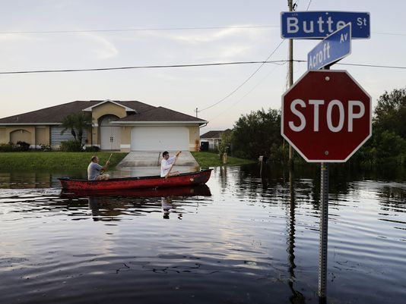
(Photo: AP) (Florida)
In the wake of two “500-year floods” (Harvey and Irma) just weeks apart, and now with Maria, too, we might wonder what would happen if there is a 500-year flood at the Jersey Shore. Both Sandy in 2012 and Irene in 2011 brought 100-year flooding. We still haven’t fully recovered from Sandy, five years later.
FEMA has flood risk maps that show what areas of the Jersey Shore would likely be under water in a 500-year flood. These include most of the areas flooded during Sandy, plus more. Likely flooded areas include the entire coast and most coastal as well as inland rivers and streams. Of course, the area that is actually flooded depends on the path of the rainfall.
Storms from the ocean have become stronger as ocean temperatures rise. This trend will continue. We may not agree on the cause of the rising temperatures, but virtually everyone agrees it is happening, and we can do something about it by slowing or drawing down the amount of carbon in the atmosphere.
There are many ways to do this: by switching to renewable energy, placing a fee on carbon, regulations to lower emissions in vehicles or energy-generation plants, and on and on. All this can be done — and will be done, sooner or later — with lower cost to the consumer, more jobs and a boost to the economy. The sooner we make this happen, the better off will be the world we leave for our children.
Pat Miller, Middletown

